Ideation Phase
Define the Problem Statements

Date | 20 Octobar 2026
Team ID: | Niharika Suhane
Project Name | IMovies - Movie ticket booking made simple.
Maximum Marks | 2 Marks

Customer Problem Statement Template:
To identify the core problems moviegoers face while searching for movies, comparing showtimes, selecting seats, and booking tickets online, and use these insights to guide the development of IMovies – Movie ticket booking made simple.
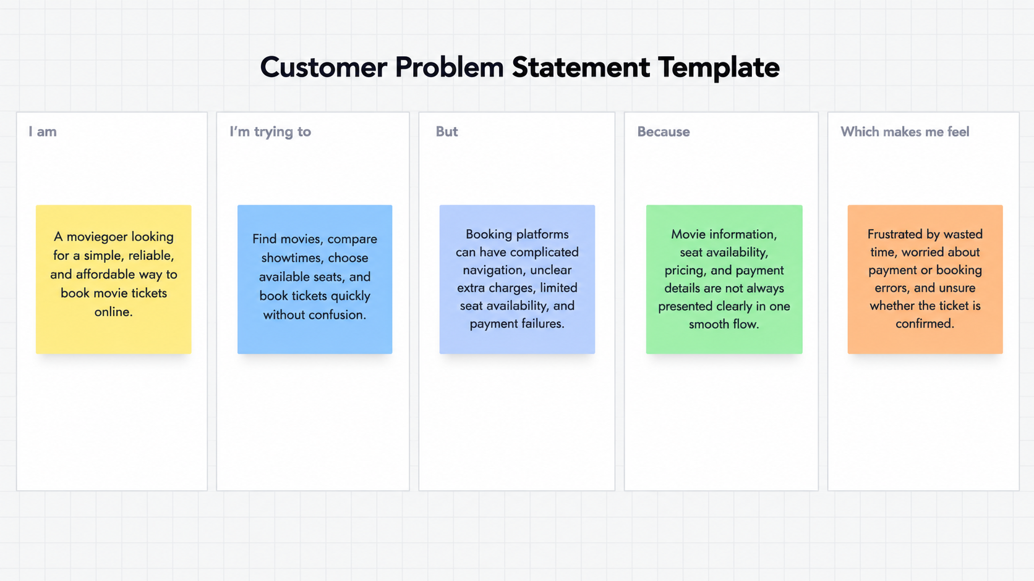
Reference: https://miro.com/templates/customer-problem-statement/

Problem Statement (PS) | I am (Customer) | I’m trying to | But | Because | Which makes me feel
PS-1 | A moviegoer | Book movie tickets quickly and easily | Booking platforms have complicated navigation and unclear pricing | Extra charges and confusing booking steps make the process difficult | Frustrated and confused
PS-2 | A regular movie enthusiast | Find the best showtimes and select preferred seats | Seats may be unavailable, and showtime information can be unclear | Popular shows fill up quickly, and information is not always easy to compare | Disappointed and stressed

